AP Calculus AB Name ___________
Worksheet – Graphs of Functions

1) The graph of is given below.
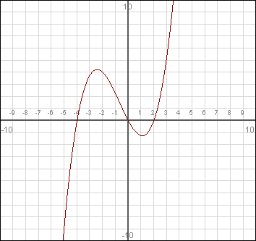

State or estimate the value of:

If , what are the values of x?

If , what are the values of x?

State the domain and range of .

On what intervals is the function increasing and decreasing?

2) The graph of is given below.
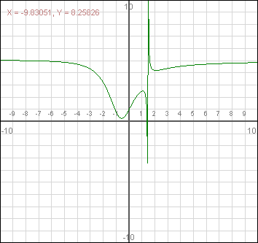

State or estimate the value of:

If , what are the values of x?

If , what are the values of x?

State the domain and range of .

On what intervals is the function increasing and decreasing?

What is occurring at approximately ?

